**Session 4: Interpreting TAMSAT-ALERT Forecasts**

In this session, you will be learning how to correctly interpret TAMSAT-ALERT soil moisture forecasts. The correct interpretation of any forecast is crucial if it is to appropriately inform decision-making. By the end of this session, you should be confident in your understanding of TAMSAT-ALERT soil moisture forecasts.

To begin, look at the figures below and answer the associated questions. Use additional space for you answers if required.

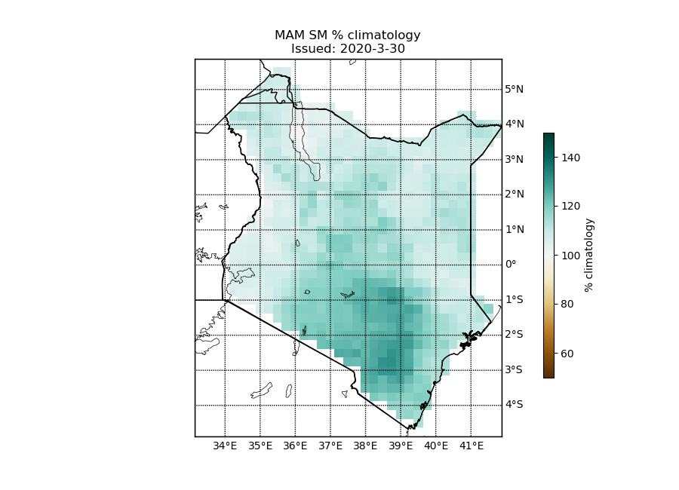**Figure 1.** Mean seasonal top-layer soil moisture forecast for Kenya. Issued on the 30th March 2020. The forecast is presented as a percentage of the climatological mean for the March-May season.

1. Based on Figure 1, what would you conclude about mean soil moisture for the 2020 March-May season?
2. Considering your own role, would you take any action or make any decisions based on this information?

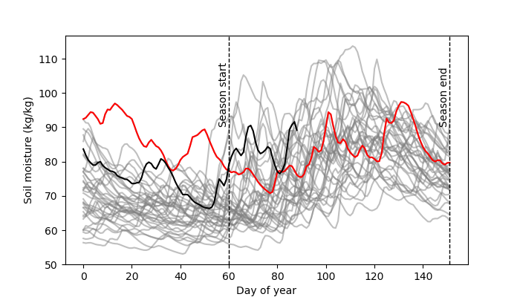**Figure 2.** The progression of top layer soil moisture throughout the year, averaged across Kenya. Issued on 30th March 2020. The grey lines show soil moisture for each year in the climatological period (1983-2019). The black line shows soil moisture throughout 2020 to date. The red line shows soil moisture in 1998 (following the heavy rains experienced during OND 1997).

1. Why do you think 1998 was highlighted in Figure 2?
2. How would you compare soil moisture in 2020 to other years in the climatology? Does this align with your conclusions in question 1?
3. How does the information differ between Figure 1 and Figure 2? What additional information does Figure 2 provide over Figure 1 and vice versa?

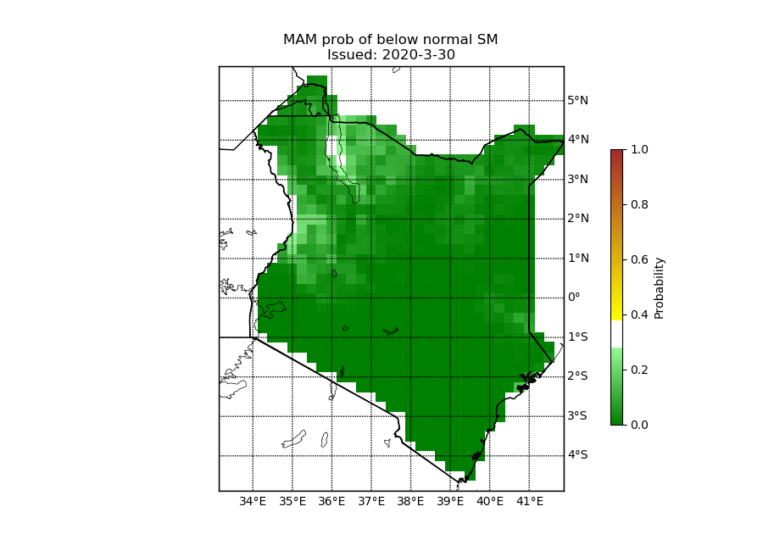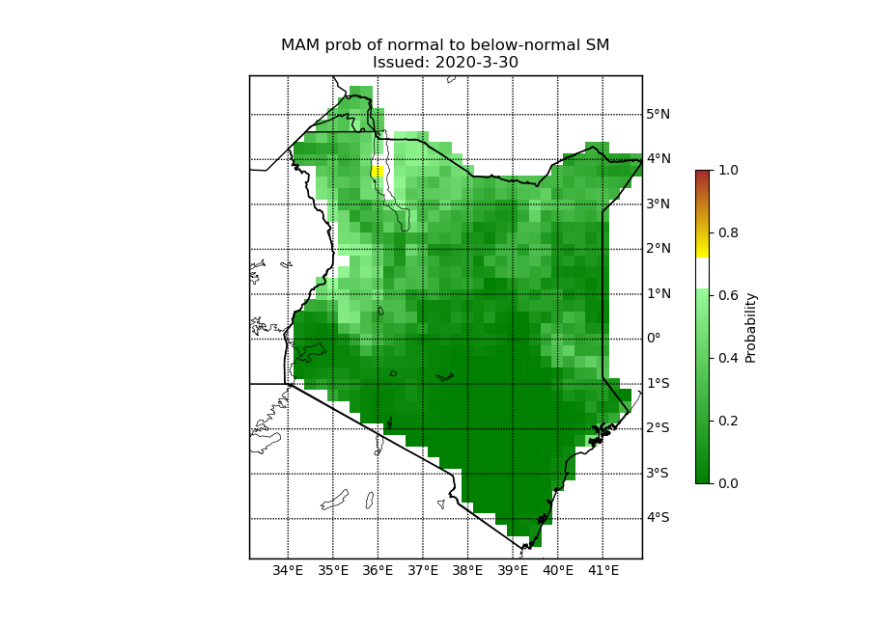

**Figure 3a and 3b.** The probability of 2020 March-May mean top-layer soil moisture being (a) below normal (lower tercile) and (b) normal tercile (mid tercile). Issued on 30th March 2020.

1. How do you interpret Figure 3a?
2. How do you interpret Figure 3b?
3. If you consider both figures together, would you conclude anything different?

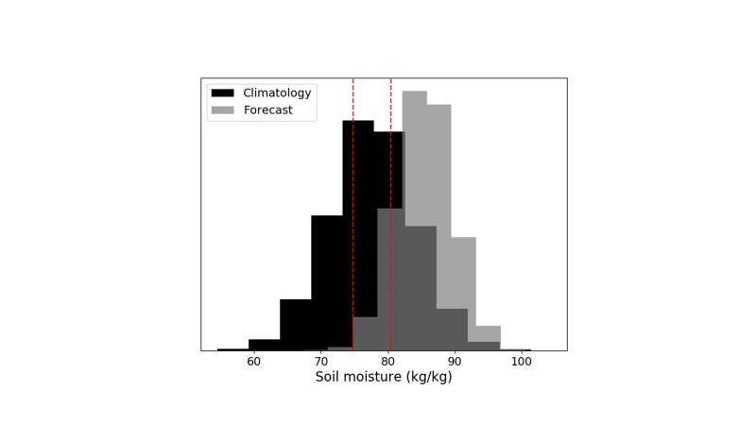**Figure 4.** The probability distribution of March-May climatological top-layer soil moisture (black bars) compared to the ensemble forecast (grey bars). Vertical red lines indicate the 33rd and 67th percentile soil moisture based on the climatology.

1. What does Figure 4 tell you?
2. Does this interpretation align with Figure 3a and 3b?
3. Does it tell you any additional information when compared with Figure 3a and 3b?

Now listen to the presentation provided for this session. It will take you through the things to consider when interpreting TAMSAT-ALERT forecasts. Once you have listened to the presentation, return to this worksheet and complete the questions below.

Reflect on the answers you gave in questions 1-11 above. Based on the information covered in the listen-along presentation, consider whether you would interpret Figures 1-4 differently now. Is there anything you would add, edit or remove? If so, use the space below to re-write your answers to questions 1-11.

Do not delete the answers you gave earlier; these will be useful for reflection and will remind you of what you have learnt. These answers are also extremely useful for us; they help us to understand how best to present the forecast information so that it is most helpful to our users. We therefore request that you return to us this completed worksheet. If you have any feedback or suggestions on the plots, please also use the space at the bottom of the worksheet to let us know. Worksheets should be sent to: [v.l.boult@reading.ac.uk](mailto:v.l.boult@reading.ac.uk). Thank you very much for your support.

Write your amended answers to questions 1-11 here:

1)

2)

3)

4)

5)

6)

7)

8)

9)

10)

11)

Please include any feedback you have on the figures below. Many thanks.